**Hello Team!Consider the below two tables**:

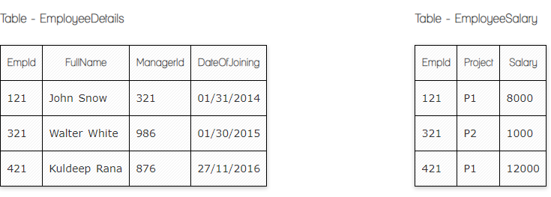

**Ques.1. Write a SQL query to fetch the count of employees working in project 'P1'.**

**Your Answer:**

**Select *;**

**FROM ‘EmployeeSalary’,**

**Where project =‘P1’**

**Ques.2. Write a SQL query to fetch employee names having salary greater than or equal to 5000 and less than or equal 10000.**

**Your Answer:**

**Select *;**

**FROM ‘EmployeeDetails’,**

**INNER JOIN EmploeeSalary On ‘EmployeeDetails’.Empld= EmploeeSalary. Empld**

**WHERE ‘Salary Between 5000 and 10.000’**

**Ques.3. Write a SQL query to fetch count of employees sorted by project's count in descending order.**

**Your Answer:**

**Select Count(Empld), Project**

**FROM ‘EmployeeSalary’,**

**GROUP BY ‘Project’**

**Order By Count (Empld) DESC**